Order Of Lenten Service

Opening Hymn: TLH 144

Reading: Lent V

The History of the Passion of our Lord

Sermon Hymn: TLH 142

Sermon Text: Luke 5:27-32

Levi The Publican

Confession of Sins: O almighty God, merciful Father, I, a poor miserable sinner, confess unto Thee all my sins and iniquities, with which I have ever offended Thee and justly deserved Thy temporal and eternal punishment. But I am heartily sorry for them and sincerely repent of them, and I pray Thee of Thy boundless mercy and for the sake of the holy, innocent, bitter sufferings and death of Thy beloved Son, Jesus Christ, to be gracious and merciful to me, a poor, sinful being.

Holy Communion

The Lord's Prayer

The Blessing

Closing Hymn: TLH 147

* * * * * * * * * * * * *

Bible Study: Lambs: Red Squirrel
Sheep: Proverbs 28:21-25
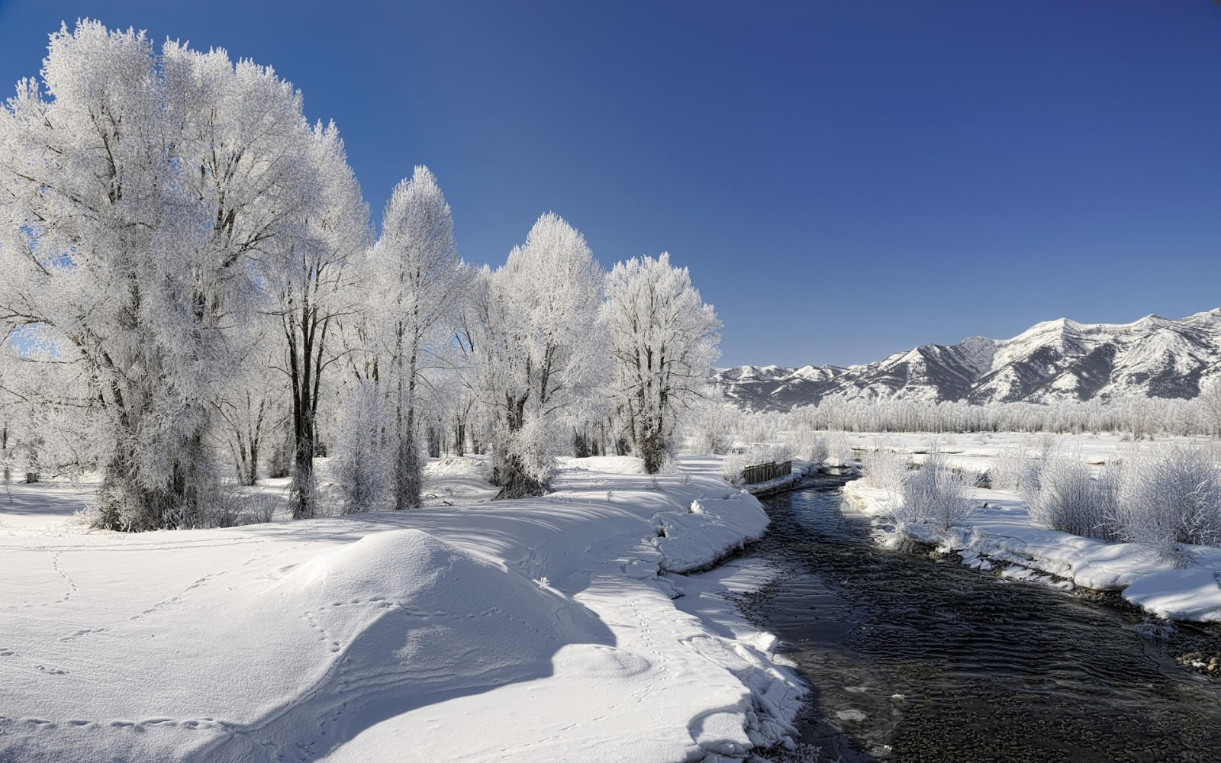

Open Water

Water
Of
Life

14 March 2021

W A T E R O F L I F E

Independent Christian Church—Conservative Lutheran Doctrine

Worship Service: 9:30 a.m. Bible Study: 10:45 a.m.

Larry Cooper, Pastor E-Mail address:
111 N. Ridge Road lcooper@wateroflife.cc
Coon Valley, WI 54623 Web Site:
www.wateroflife.cc

* * * * * * * * * * * * * * * * * * * * * * * * * * *

Sermon Text: Luke 5:27-32

Levi The Publican

* * * * * * * * * * * * * * * * * * * * * * * * * * *

27 And after these things he went forth, and saw a publican, named Levi, sitting at the receipt of custom: and he said unto him, Follow me.
28 And he left all, rose up, and followed him.
29 And Levi made him a great feast in his own house: and there was a great company of publicans and of others that sat down with them.
30 But their scribes and Pharisees murmured against his disciples, saying, Why do ye eat and drink with publicans and sinners?
31 And Jesus answering said unto them, They that are whole need not a physician; but they that are sick.
32 I came not to call the righteous, but sinners to repentance.

